Alexander Richin

20055282

Username: ajr86bd

CMPT 220 : Software Development 1

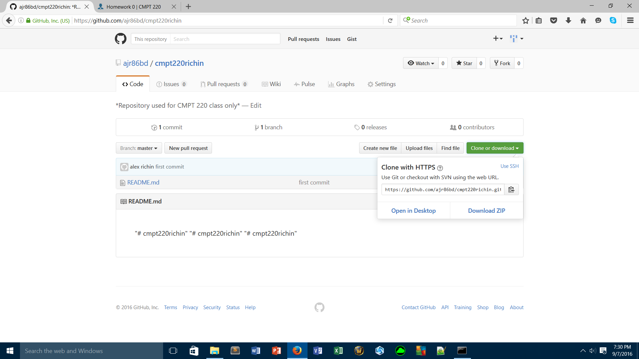

<https://github.com/ajr86bd/cmpt220richin.git>

